Assignment 2

Name: Lukas Pfalz

ITS 1110

Section: CSC-1110-71762

# **Assignment 2**

***COMPLETE THE HONOR CODE BELOW***

**HONOR CODE:**

I pledge that this program represents my own program code, I have received help from no one and I have given help to no one.

**OR**

I received help from **NAME OR NO ONE** in designing and debugging my program.

I have given help to **NAME OR NO ONE** in designing and debugging my program.

This assignment is required.

The grading form shows point values for this assignment. Please review it now.

Show screen shots of the python code with comments and your input/output window.

You should use several well-planned sets of data to check out your program. Testing your programs with just the data that is asked for in the assignment does not necessarily mean that the programs will work for all cases.

Please include the following comments in each of your Python programs:

Your Name

Section

Date

Description

Assignment Number

A python template (python_template.py) has been provided for you to use.

Name this document XXX_Assignment 2 where XXX are your initials. Include a python file named P01.py, P02.py, etc. for each problem.

1. Personal Information: Use the Python command shell to print out the following information (this does not have to be your information):

• name

• address, with city, state, Zip code

• telephone number

• College major

**PLACE SCREEN SHOTS OF THE PYTHON CODE AND ALL I/O HERE.**

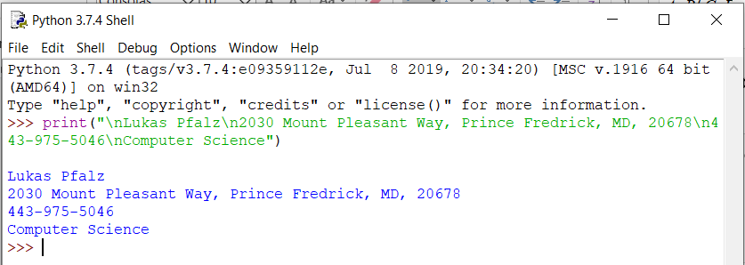

## Write a program that does the following:

* Create four variables that store the following pieces of data. Be sure to name your variables in a way that makes sense to someone else (i.e. don't name your variables something simple that doesn't relate to the data that is being stored (like 'x' or 'y')).
* A class name (store the string: Program Design and Development)
* Test #1 average (store the number: 95)
* Test #2 average (store the number: 76)
* Test #3 average (store the number: 87)
* Using the print function and your variables, generate the following output. Note the formatting in the output below - make your program match the formatting exactly.
* Average Test Scores For "Introduction to Computer Programming":
* - Test #1: 95
* - Test #2: 76
* - Test #3: 87

Comment your source code and describe your code to someone who may be viewing it for the first time.

**PLACE SCREEN SHOTS OF THE PYTHON CODE AND ALL I/O BELOW.**

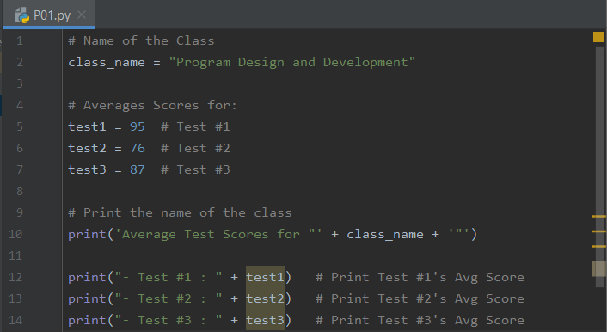

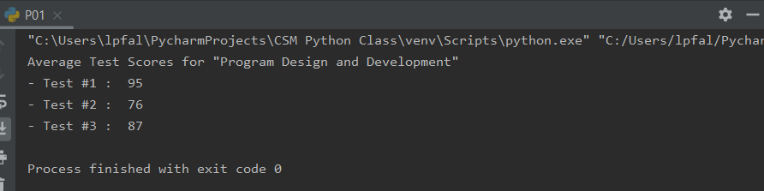

## Write a program that prompts the user to enter 3 names. Store each name in a separate variable. Then display the names back to the user in every possible order.

* Print the first three combinations all on one line separated by commas.
* Print the second three combinations with one name per line.

Note the formatting in the output below - make your program match the formatting exactly.

Sample input/output:

Please enter name #1: Allison

Please enter name #2: Jeremy

Please enter name #3: Emily

Here are your names in every possible order:

--------------------------------------------

Allison, Jeremy, Emily

Allison, Emily, Jeremy

Jeremy, Allison, Emily

Jeremy

Emily

Allison

Emily

Jeremy

Allison

Emily

Allison

Jeremy

Comment your source code and describe your code to someone who may be viewing it for the first time.

**PLACE SCREEN SHOTS OF THE PYTHON CODE AND ALL I/O BELOW.**

